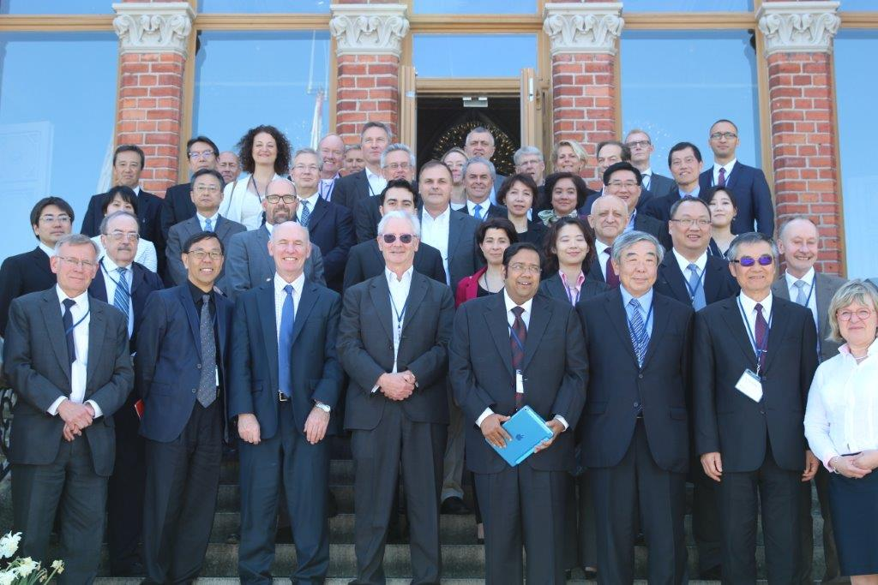**

**29th ANNUAL GENERAL MEETING l STOCKHOLM l 22 – 24 May 2016 2016**

**HOST**